13.98: Denote the position of a piece of the spring by 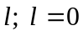is the fixed point and 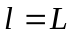is the moving end of the spring. Then the velocity of the point corresponding to denoted 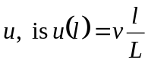 (when the spring is moving, will be a function of time, and so is an implicit function of time). a) 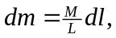 and so

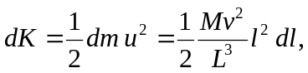
and
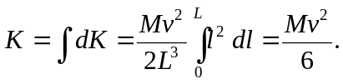

b) 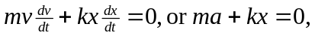 which is Eq.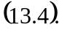 c) is replaced by 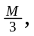so 